Report for: | Planning Policy Advisory Panel
Date of Meeting: | 4th May 2023
Subject: | Proposed West Drive and Bellfield Avenue Conservation Area designation – outcomes of consultation and recommendations
Key Decision: | No
Responsible Officer: | Viv Evans, Chief Planning Officer.
Portfolio Holder: | Councillor Marilyn Ashton, Deputy Leader of the Council, Planning & Regeneration Portfolio Holder.
Exempt: | No
Decision subject to Call-in: | No
Wards affected: | Harrow Weald
Enclosures: | Appendix 1 – Map of proposed conservation area subject to consultation  Appendix 2 – Revised conservation area boundary post-consultation  Appendix 3 – Consultation report

Section 1 – Summary and Recommendations
This report details the outcomes of the recent consultation on the proposed West Drive and Bellfield Avenue conservation area in Harrow Weald (Appendix 1). The consultation ran for a period of six weeks from 20 February 2023 to 3 April 2023. This matter was previously considered by the Panel at its meeting on 30 November 2022; at its meeting on 19 January 2023, Cabinet agreed to the Panel’s recommendation that consultation be occur on the proposed area.

As a result of consultation responses received (documented in section 6) the report recommends two minor amendments proposed conservation area boundary; these amendments remove 30 and 32 Bellfield Avenue from the proposed conservation area and include 128, 130 and 132 Uxbridge Road. The revised boundary is shown in Appendix 2 and comprises 1-41 (consecutive) West Drive, 1-29, 31, and 33-47 (consecutive) Bellfield Avenue, all of West Drive Gardens and 128, 130 and 132 Uxbridge Road.

Recommendations:

The Planning Policy Advisory Panel is requested to:

Note and comment on the outcomes of the consultation undertaken on the proposed West Drive and Bellfield Avenue conservation area;

Note and comment on any responses received as a result of the additional letters sent in response to comments received during the formal consultation period and impacting upon the proposed boundary (to be reported verbally to the Panel meeting)

Note and comment on the amended proposed conservation area boundary; and

Recommend the revised area to Cabinet for designation as the ‘West Drive and Bellfield Avenue, subject to any further consultation responses received (which will be formally reported to Cabinet).

Reason:

Conservation Areas are designated under the Listed Buildings and Conservation Areas Act 1990 (‘the Act’) which states in section 69 that 'every local planning authority shall from time to time determine which parts of their area are areas of special architectural or historic interest the character or appearance of which it is desirable to preserve or enhance, and shall designate those areas as conservation areas'. Consideration of the proposed area as a possible conservation area therefore fulfils Section 69 of the Act.

Section 2 – Report

1.0 Introductory paragraph

1.1 The report incorporates the corporate priority concerning:
- Putting Residents First

1.2 Should the area be designated as a conservation area status, the improved protection of areas of special architectural or historic interest will help maintain the unique historical local character of areas or neighbourhoods within Harrow which residents cherish and value. It also contributes to the overarching objective to restore pride in Harrow.

2.0 Options considered

2.1 The option of not reviewing the area for consultation area status was considered but this would be contrary to the Council’s statutory obligations under the Planning (Listed Buildings and Conservation Areas) Act 1990, under which local planning authorities are required to carry out reviews ‘from time to time’ to ensure areas are adequately protected.

2.2 The option not to consult on the proposed area was considered and dismissed. This is because whilst consultation is not a statutory requirement it is best practice and doing so reflects the corporate priority of Putting Residents First.

2.3 The body of this report outlines options (and recommendations) in response to responses received to the consultation, including whether to designate the area as a conservation area and whether or not to amend the boundary in response to comments received during consultation.

3.0 Background – what is a conservation area

3.1 Conservation Areas are designated under the Listed Buildings and Conservation Areas Act 1990 which states in section 69 that 'every local planning authority shall from time to time determine which parts of their area are areas of special architectural or historic interest the character or appearance of which it is desirable to preserve or enhance, and shall designate those areas as conservation areas'.

3.2 In order for an area to be appropriate for designation as a conservation area, it must fulfil two of the following criteria as outlined in the four SPDs covering the borough’s existing conservation areas:

- Areas with a high concentration of Listed Buildings, whether statutorily or locally listed;
- Areas of historical, social, economic and/or architectural merit;
- Areas with a high proportion of buildings built prior to 1920, which remain largely unaltered;
- Areas built post 1920 that are innovative in planning or architectural detail, and where a large proportion remain unaltered;
- A significant group of buildings with distinct physical identity and cohesiveness;
- Areas which have a special quality, where the site layout and landscaping are of exceptionally high quality and/or contain historic open space, natural landmarks, topographical features or features of local distinctiveness

When not to designate?

3.3 The National Planning Policy Framework (NPPF) (2021) states in paragraph 191 that:

‘When considering the designation of conservation areas, local planning authorities should ensure that an area justifies such status because of its special architectural or historic interest, and that the concept of conservation is not devalued through the designation of areas that lack special interest’.

3.4 Historic England are the Government’s advisers on matters of heritage. They have published guidance entitled: ‘Conservation Area Appraisal, Designation and Management Historic England Advice Note 1’ [HEAN 1] (Second Edition) – February 2019. They highlight the above requirement of the NPPF twice in their guidance since it was also contained in earlier iterations of the NPPF.

3.5 In addition, HEAN1 mirrors the requirements of s.69 of the LBCA 1990 that there shall be both ‘special interest’ and ‘desirability to preserve or enhance’ for CA designation as it states in paragraph 11 that there is: ‘likely to be a stage when a decision would need to be taken as to the significance of an area and the likelihood of conservation area designation addressing relevant problems within the area. This is unlikely to be a lengthy process, the purpose being to consider whether an area has:

a) sufficient architectural or historic interest for the area to be considered ‘special’?
b) whether this is experienced through its character or appearance? and
c) whether it is desirable for that character or appearance to be preserved or enhanced, and what problems designation could help to solve’.

3.6 Thus, it indicates that where an area meets the criteria for designation, on occasion designation may not be desirable and prompts consideration as to what problems designation could help solve in order to determine the desirability of designation.

4.0 Background - Proposed West Drive and Bellfield Avenue Conservation Area

4.1 At its meeting on 30 November 2022 the Planning Policy Advisory Panel considered a report on three areas for potential conservation area designation against the local criteria for designation (set out in paragraph 3.2 above).

4.2 Two of the areas were considered not to meet the Council’s local criteria for designation.

4.3 The case for the third area (West Drive Gardens, Bellfield Avenue and West Drive numbers 1- 41 (odd) and 2-36 (even), Harrow Weald) was considered by officers as ‘marginal’. Section 6 of the Panel report (see background papers) provides details of the assessment and conclusions for the area.

4.4 The Panel was requested to: ‘consider the outcomes of the assessment of the areas to be considered for conservation area status and provide any comments’.

4.5 In the discussion that ensued, Members noted that:

the background to the West Drive / Bellfield Avenue area was acknowledged. The observation made was that the 2015 consultation set the bar too high with respect to residents demonstrating how the area met the local criteria. Members and officers acknowledged that the case for inclusion in a Conservation Area was marginal (as noted in the assessment). However, on balance the area should proceed to consultation for potential inclusion in a Conservation Area. The suggested name was West Drive and Bellfield Avenue Conservation
Area.

4.6 The West Drive and Bellfield Avenue area should proceed to consultation for potential designation as a new Conservation Area and that recommendation was agreed by Cabinet at its meeting on 19 January 2023.

5.0 Consultation arrangements

5.1 Residents of the proposed conservation area were sent letters informing them of the consultation (99 letters in total). These letters included information on the dates, context and ways to get involved in the consultation. QR codes were included on the letters to provide a direct and easy to access link to the engagement platform webpage which was run through the Council’s My Harrow Talk (Engagement HQ) page.

5.2 Hard copy site notices were printed, laminated and placed around the proposed conservation area on streetlamps. The site notices gave a summary of the consultation including dates and ways to respond. A QR code was also included on the site notices to provide a direct link to the engagement platform webpage which provided a survey, that all those viewing the platform webpage could fill in once if they wished.

5.3 The online platform included a survey included three questions in relation to the proposal, in order to be straightforward and simple to respond to, avoiding unnecessary or confusing questions. Participants were required to register in order to respond to the survey, this ensures that the respondents are real people with email addresses. The survey could only be responded to once by each registered user.

5.4 Details of the consultation were also sent to Historic England in their role as Government’s advisers on matters of heritage and publishers of official guidance in relation to conservation areas.

5.5 As a result of comments received as a result of the consultation, additional letters were sent to four additional properties (three proposed to be included and one removed), as outlined in section 6 below.

6.0 Outcomes of the Consultation

6.1 The consultation saw a total of 16 responses, with the majority of these in support of the proposed conservation area.

6.2 The online survey saw 10 respondents overall with eight of these living within the conservation area. Eight of these supported the inclusion of the area within a new conservation area (with one suggesting the boundary be extended to include some houses on the Uxbridge Road at the entrance to West Drive), whilst noting the criteria for conservation area status. In contrast, two did not support inclusion.

6.3 There were also six emails/letters of response. It is unclear if there was any overlap between these respondents and those in the online survey. Of those six emails/letters: three were in support, one against, one requested the boundary be amended to exclude 30 and 32 Bellfield Avenue (based on the age and character of these properties), whilst Historic England noted: ‘There does not appear to be a clear case made for the special architectural and historic interest of the area to warrant designation’.

Comments in support

6.4 Those in support of inclusion noted the area should not have been de-designated and stated that both Bellfield Avenue and West Drive are representative of vernacular suburban architecture of the 1930s with a leafy relaxed atmosphere. Comments also noted there is a distinct physical identity and cohesiveness. It was intended to have a variety of styles of architecture of the properties. It was noted that the area was enjoyed by runners and the risk is that this identity will be destroyed by unsympathetic modernisation, greater hard-standing, more extensions and, worst, by demolishing and replacing the existing housing stock. The Conservation Area will help prevent that happening.

6.5 It was noted that past arguments put forward for Conservation Area status remain valid and have been strengthened over time. It was stated that the case for designation should be considered in the context of the wider neighbourhood, where changes have significantly diminished the traditional suburban aesthetic. It was noted that Bellfield Avenue and West Drive have retained much of their inter-war character, with individual detached properties set in large mature gardens flanking the original estate boundaries. It was noted that the area was once part of the Harrow Weald Park Estate and that designation would protect a coherent picture of the origins the estate. Comments were made about the former Harrow Weald Park Estate area as a whole including that outside of the existing proposed conservation area as being designated a green belt area, parts considered a ‘place of natural beauty’ with a natural lake home to various bird species.

Comments seeking changes to proposed boundary

6.6 It was noted that houses at the entrance of West Drive on both side of the street i.e. those on Uxbridge Road should be included in the conservation area as they have significant architectural interest. A review of these houses suggests they have merit for inclusion given the character and interest of the proposed conservation area. 128 Uxbridge Road is locally listed as a building of special architectural and historic interest and the local list entry reads: ‘Mock Tudor house of some quality dating from 1931, designed by GH Lake featuring mock timber framing and attractive leaded light windows. Number 130 and 132 Uxbridge Road appear to be of similar age and design.

6.7 Consequently additional consultation was undertaken, letters were sent to these houses: 128, 130 and 132 inviting comment from 6th April to 3rd May on the proposed inclusion of each property in the conservation area. The results will be verbally reported to the Panel at its meeting and formally documented in any subsequent report to Cabinet.

6.8 Similarly, it was requested by one respondent living in one of these houses that numbers 30 and 32 Bellfield Avenue should not be included in the proposed conservation area as they are much more modern houses as per those built at a similar time on Templars Drive and Lakeland Close. Council review shows these two houses are indeed more akin in age and design to the modern houses along Templars Drive and Lakeland Close that are being excluded from the proposed conservation area, and so the case for exclusion has merit.

6.9 Consequently additional consultation was undertaken, letters were sent to the remaining house on Bellfield Avenue of numbers 30 and 32 inviting comment from 6th April to 3rd May, on the proposed inclusion of each property in the conservation area. The results will be verbally reported to the Panel at its meeting and formally documented in any subsequent report to Cabinet.

Comment objecting to designation of the conservation area

6.10 The response against suggested the area does not have a high concentration of listed buildings, has no historical or architectural history left. Many of the houses have been modernised and there is no group of buildings with distinct physical identity. It stated that they saw no benefit therefore for including this in a conservation area. It was observed that the area does not meet the listed criteria to be a conservation area i.e. many of the houses are newly renovated and extended with no original architectural value or distinct physical identity or any historical value. It was also suggested that designation as a conservation area would ‘only add an onerous burden of bureaucracy to residents wishing to modernise their homes’. Therefore, it was stated that there was strong disagreement with this proposal.

6.11 The concerns regarding the level of architectural and historic interest are noted. Such comments reflect the fact that the report considered by the Panel at its meeting on 30 November 2022 concluded that the case for designation was marginal; as noted above, more responses were in support of designation than against it. Any additional planning requirements arising from designation are intended to assist in the preservation of the area’s interest.

Historic England’s response

6.12 Historic England are the Government’s advisors on heritage and were consulted as part of the overall consultation process. They noted that the National Planning Policy Framework (NPPF, 2019) requires that heritage assets be conserved in a manner appropriate to their significance. NPPF Policy 191 sets out that when considering the designation of conservation areas, local planning authorities should ensure that an area justifies such status because of its special architectural or historic interest, and that the concept of conservation is not devalued through the designation of areas that lack special interest. Whilst noting the assets of the proposed conservation area including its attractive and leafy streets of detached suburban houses dating, predominantly, from the inter-war period, and its low-rise development, they conclude that:

‘Overall the area is not notable for its local architectural or historic significance. As noted in the report, the area does not possess a historic or consistent architectural character that would demonstrate a strong case for designation when considered against NPPF Policy 191. Additionally, the extent of existing accumulative alterations has to some extent undermined any consistency of architectural or historic character. The layout of the streets is not notably innovative or reflecting patterns of historic land use. In our view, therefore there does not appear to be a clear case made for the special architectural and historic interest of the area to warrant designation’.

6.13 They further noted:

- ‘The area is characteristically similar to other undesignated suburban areas within the borough and the Council must therefore also weigh up the wider implications of designation in respect of establishing a precedent in respect of the wider characterisation of the borough’.
- ‘The Council will also need to consider, given the area’s marginal interest, whether conservation area status is likely to be an effective tool to preserve or enhance its character and appearance. Given the extent of existing alteration and the areas marginal significance, designation would seem unlikely to be effective in managing future change’
- ‘NPPF Policy 191, sets out a requirement for local authorities to ensure that an area justifies such status because of its special architectural or historic interest. For the reasons set out above we do not consider a clear case for designation is set out in this instance’.

6.14 As a final point they note that in the event of the Council is minded to designate the conservation area despite the above, they would recommend that a full appraisal and area management plan is undertaken as soon as possible.

6.15 Appendix 3 provides further detail in relation to the consultation outcomes.

7.0 Discussion and recommendation

7.1 There is clear support from residents for the principle of designating the area as a conservation area, notwithstanding the receipt of three objections. Two representations suggested amendments to the proposed boundary, as outlined in Section 6 above. In response to this, the proposed boundary has been amended to include those houses along the Uxbridge Road (128, 130 and 132) with architectural and historic merit at the entrance to this proposed Conservation Area, whilst to exclude numbers 30 and 32 Bellfield Avenue which are relatively modern houses that do not relate to the remainder of the proposed Conservation Area. Further consideration may need to be given to these proposed boundary changes depending on any responses received from the affected properties, with these due on 3 May 2023 (after the publication of the agenda).

7.2 Historic England’s response re-iterates the NPPF requirement (paragraph 191) for local authorities to ensure that an area justifies such status because of its special architectural or historic interest and state they do not consider a clear case for designation is set out in this instance. This and the marginal nature of the area with respect to the conservation area criteria were documented in the report to the Panel on 30 November 2023, with the Panel concluding ‘that the case for inclusion in a Conservation Area was marginal (as noted in the assessment). However, on balance the area should proceed to consultation for potential inclusion in a Conservation Area’. As noted above, the consultation has indicated clear support for the designation from residents. Historic England note that in the event that the Council designates the area, it is recommended that a full appraisal and area management plan is promptly undertaken.

7.3 In the context of the above, it is recommended that the Panel commend to Cabinet the designation of the area (subject to amendments to the boundary identified in paragraph 7.1) as a conservation area.

Ward Councillors’ comments – these will be invited when the agenda for the Panel’s meeting is published.

Data Protection Implications

Any personal data collected as part of the consultation process has been and will continue to be handled in a manner consistent with the General Data Protection Regulations (GDPR).

Risk Management Implications

Risk included on Directorate risk register? No

Separate risk register in place? No

There are no significant risks arising from the recommendations. A full risk assessment section will be completed when the matter is reported to Cabinet.

Legal Implications

The Council has a statutory duty and is required under section 69(2) of the Planning (Listed Buildings and Conservation Areas) Act 1990 to carry out reviews ‘from time to time’ to determine whether any parts or further parts of their area should be designated as conservation areas; and if it so determines, that part(s) shall be so designated.

Should Cabinet resolve to designate the area as a conservation area, section 70 (5) of the Act requires the Local Planning Authority to give notice to the Secretary of State and Historic England (‘the Commission’). Section 70 (8) requires that notice of designation is published in the London Gazette and in at least one newspaper circulating in the area of the local planning authority.

Financial Implications

The costs of undertaking the consultation have been met from within the existing revenue budgets of the Council’s Planning Policy team. If any further action is required (such as undertaking the process to designate a conservation area), any costs will also be met from existing revenue budgets.

Equalities implications / Public Sector Equality Duty

Was an Equality Impact Assessment carried out? No

An Equalities Impact Assessment (EqIA) is not considered necessary in respect of the designation of a conservation area. Such a proposal is based on the architectural and historic merit of an area. Furthermore, the higher order Local Plan policy that contains the criteria against which development within Conservation Areas is assessed was subject to an equalities impact assessment prior to its adoption. The consultation recommended in this report would be undertaken in accordance with adopted Council standards, such as the Statement of Community Involvement (SCI).

Council Priorities

The decision sought will help the Council meet the priority of improving the environment and restoring pride in Harrow by helping ensure the attractiveness of the borough as a place to live and demonstrating that the Council seeks and listens to the views of its residents (by putting residents first).

Section 3 - Statutory Officer Clearance
Statutory Officer: Jessie Man
Signed on behalf of the Chief Financial Officer

Date: 21 April 2023
Statutory Officer: Jimmy Walsh
Signed on behalf of the Monitoring Officer

Date: 25 April 2023
Chief Officer: Viv Evans
Signed off by the Chief Planning Officer
Date: 26 April 2023

Mandatory Checks

Ward Councillors notified: YES

EqIA carried out: NO – refer to above

EqIA cleared by: N/A

Section 4 - Contact Details and Background Papers
Contact: David Hughes, Planning Policy Manager, david.hughes@harrow.gov.uk
Background Papers:
Harrow Conservation Areas and Supplementary Planning Documents (SPDs) - https://www.harrow.gov.uk/planning-developments/biodiversity-conservation

Planning Policy Advisory Panel report (30 November 2023) (item 18) - Agenda for Planning Policy Advisory Panel on Wednesday 30 November 2022, 6.30 pm – Harrow Council

Cabinet report (19 January 2023) (item 88) - Agenda for Cabinet on Thursday 19 January 2023, 6.30 pm – Harrow Council

Appendix 1 – Map of proposed conservation area subject to consultation

West Drive Gardens, Bellfield Avenue and numbers West Drive1- 41 (odd) and 2-36 (even), Harrow Weald
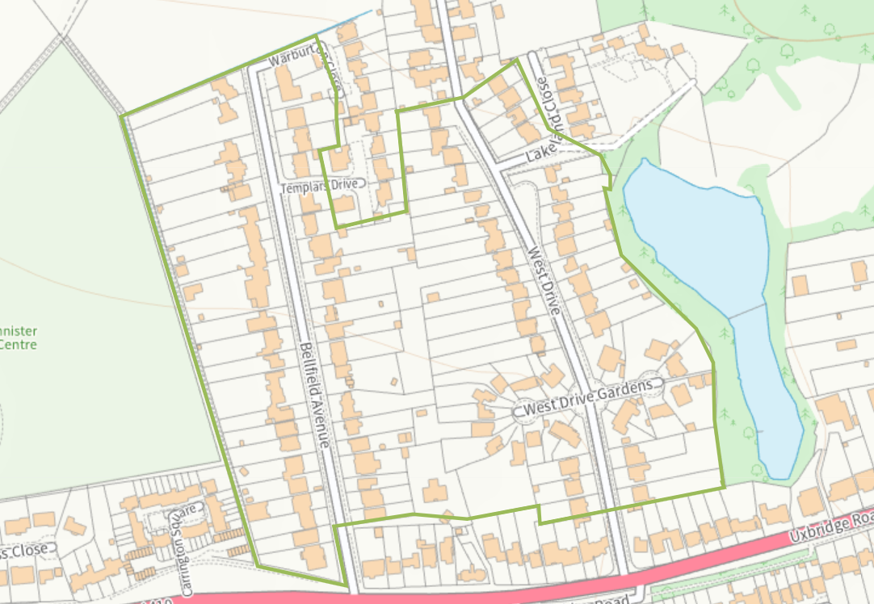

Appendix 2 – Revised conservation area boundary post-consultation

1-41 (consecutive) West Drive, 1-29, 31, and 33-47 (consecutive) Bellfield Avenue, all of West Drive Gardens and 128, 130 and 132 Uxbridge Road.
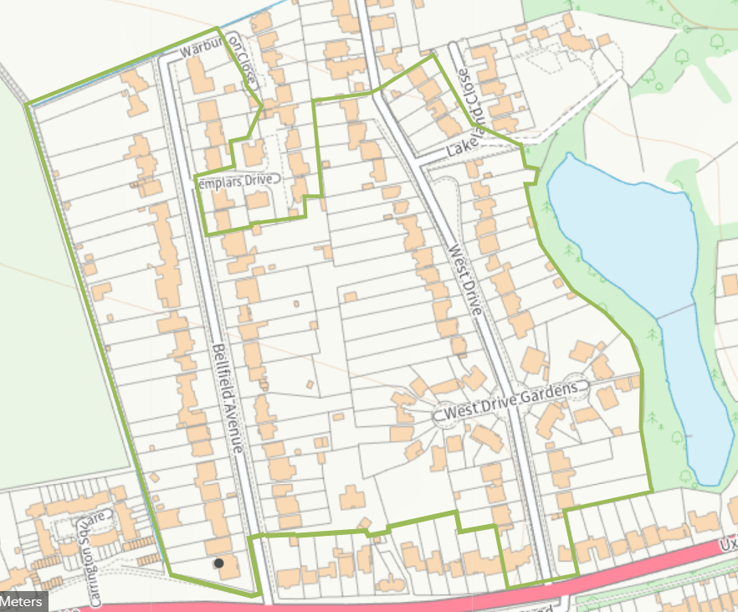

Appendix 3 – Consultation report

See separate document

These criteria were originally agreed by the Development Control Committee on 31 August 1998 as the criteria to be adopted in Harrow.

